How to download Public Library Books to your NOOK

Needed
*Nook
*Nook USB cord
*Valid library card with PIN #
*Personal Computer

1) Create a free Adobe ID (Needed to download software in next step) Go to website link below and complete information. Use the same email that you registered your Nook under.
https://www.adobe.com/cfusion/membership/index.cfm?nl=1&nf=1&loc=en_us

2) Download Adobe Digital Editions to your computer. Go to below website and click on “Download”
http://www.adobe.com/products/digitaleditions/

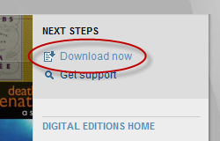

3) Go to the public library website below
http://dbooks.wplc.info/69829928-7B94-4FED-83DF-51FEEC67FCEC/10/355/en/Default.htm

4) Go to the top right hand corner of the website and click on “sign-in” & select your library system listed on your library card. Enter in your library card # and PIN #
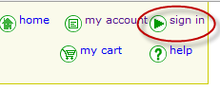

5) Click on the link on the left hand side of the screen “Currently Available ebooks” as seen below 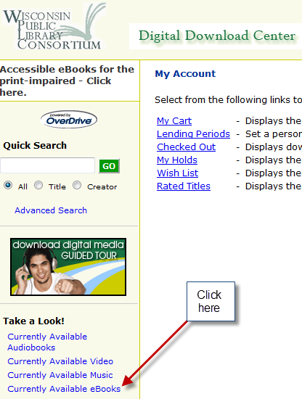

6) When you find the ebook you would like to check out, click the link to the right of the book “Add to my cart” as seen below:

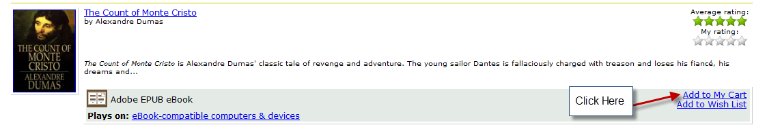

7) Once you have added the ebook to your cart, click on “my cart” then click on “proceed to checkout”
As seen below:

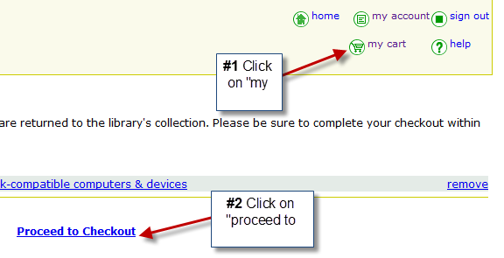

8) Now that your book is checked out, click on the green “download” button as seen below:

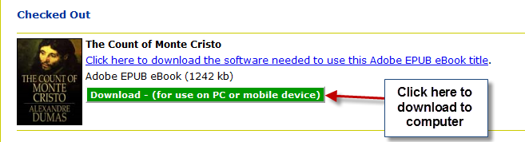

9) Once you hit the download button a box will appear. Make sure “Open with” is selected and the program to open it with is “Adobe Digital Editions” as seen below
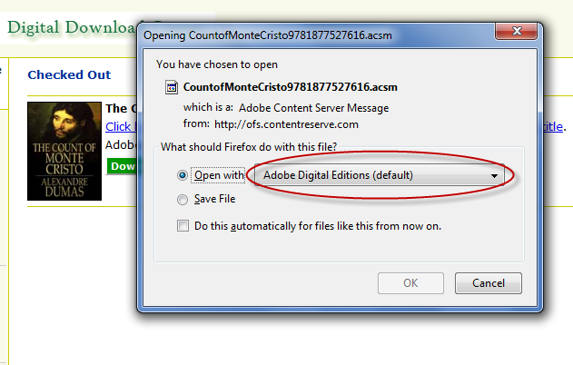

10) Once the book is completely downloaded, go to “Library View” within Adobe Digital Editions by clicking on the book icon located in the top left hand corner, see below:

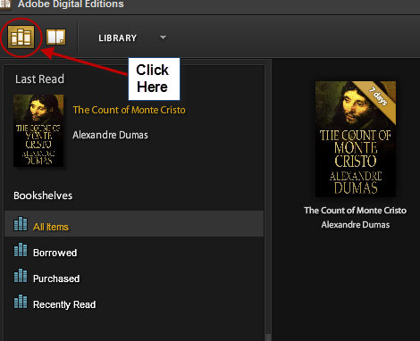

11) Plug in your Nook to your computer using the USB cord. Click “Authorize Device” on pop-up window then click on the ebook itself while you drag and drop it into the Nook bookshelf seen on the left. See below:
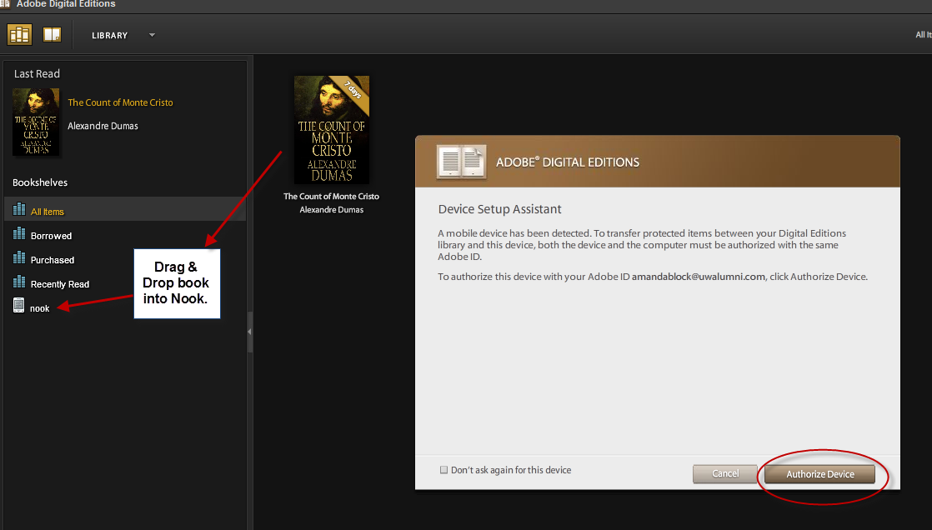

12) After ebook is transferred, safely remove Nook from computer. Open ebook on the Nook Classic: Go to Library→My Documents. Open ebook on Nook Color: Go to Library→ My Files → Digital Editions

